|  |
| --- |
| Data Analysis Hollywood Movie Project |
| Assignment 3 |

|  |
| --- |
| Lozarta V  5-31-2024 |

**R Studio**

I loaded the Hollywood Movie dataset into R studio as CSV, cleaned it and ran summary statistics, exporting as CSV. Below is a screenshot from the script editor in R studio.

**Explanation of steps:**

1. Loading data: reads file in CSV format, creating a data frame from it – assigning data frame to the variable df

df<- read.csv("<https://public.tableau.com/app/sample-data/HollywoodsMostProfitableStories.csv>")

1. Viewing data: allows user to view the data table

View(df)

1. Loading library: tidyverse packages loaded for data analysis, ‘tidy data’.

install.packages("tidyverse")

1. Importing library: tidyverse imported

library(tidyverse)

1. Checking data types: the data types used are Numeric (integers & float), Integer(whole number), Char(string of text).

str(df)

1. Checking for missing values: important to identify for data analysis

colSums(is.na(df))

1. Dropping missing values: in order to handle missing values, in this case the amount of missing data is small

df <- na.omit(df) or df <- df %>% drop_na()

1. Checking to make sure the rows have been removed

colSums(is.na(df))

1. Summary statistics: exploratory data analysis

summary(df)

1. Scatterplot: exploratory data analysis

ggplot(df, aes(x=Lead.Studio, y=Rotten.Tomatoes..)) + geom_point()+ scale_y_continuous(labels = scales::comma)+coord_cartesian(ylim = c(0, 110))+theme(axis.text.x = element_text(angle = 90))

1. Bar Chart: exploratory data analysis

ggplot(df, aes(x=Year)) + geom_bar()

1. Exporting clean data: CSV file created as clean_df.csv

write.csv(df, "clean_df.csv")

Below is a screenshot showing steps from loading the data to checking the data types.

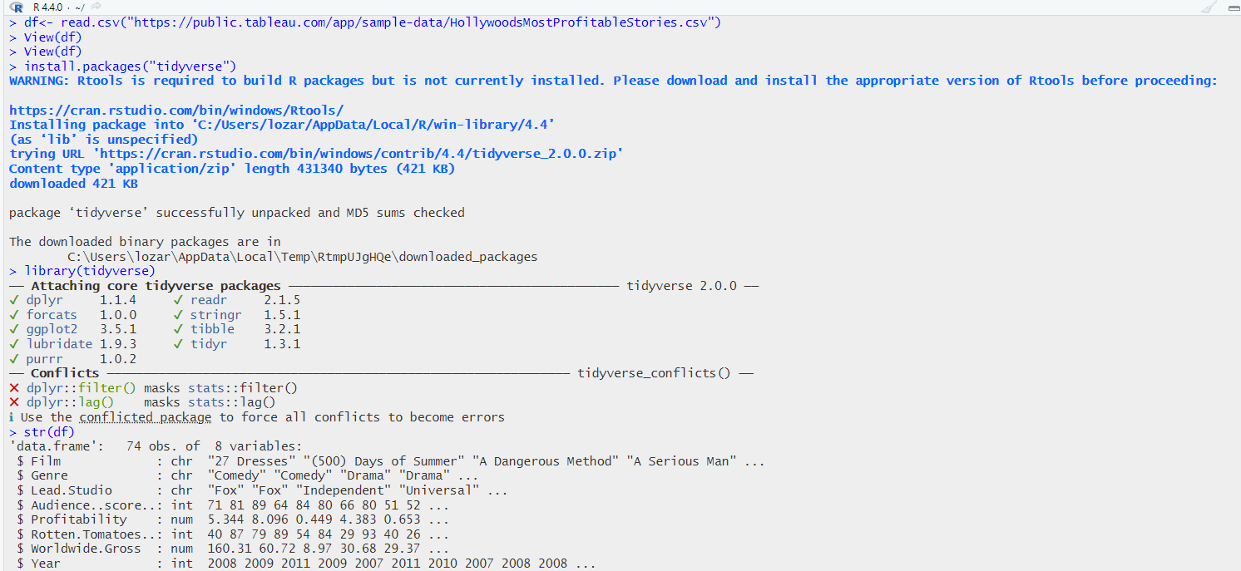

This screenshot shows steps from checking for missing values to exporting clean data as CSV.

Exploratory Analysis

**Exploratory Analysis**

The scatter plot below shows each lead studio by the number and spread of Rotten Tomatoes ratings.

The bar chart below shows the count of films for each year.

In addition, I produced a bar chart for count of each genre below.I also produced a boxplot of lead studios and Rotten Tomatoes ratings.

**Power BI Dashboard**

Below is a screenshot of my Power BI dashboard, after importing the CSV and transforming the data.

In the table view, I changed the column names for better readability, as well as reducing the number of decimal points for the Profitability and Worldwide Gross. I also set the ‘count’ of films by year, and calculated the average Rotten Tomatoes Rating by Genre using a DAX calculation.

